**Magento Promotions Related Tables:**

**Two Types**

* Catalog Price rule
* Cart Price rule

**Catalog Price rule related tables in database**

* catalogrule
* catalogrule_customer_group
* catalogrule_group_website
* catalogrule_group_website_replica
* catalogrule_product
* catalogrule_product_price
* catalogrule_product_price_replica
* catalogrule_product_replica
* catalogrule_website

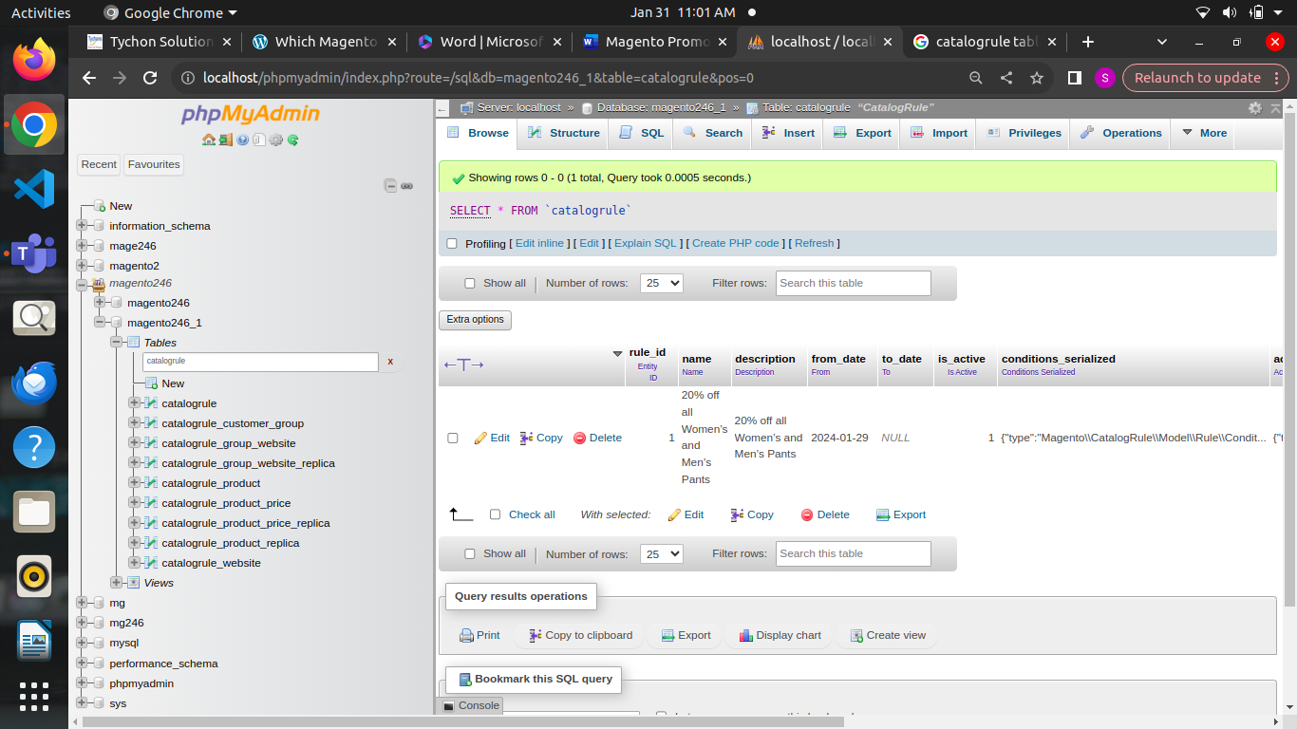

**catalogrule:**

* In Magento 2, the catalogrule table in the database is part of the database schema used to manage catalog price rule
* Catalog price rules allow administrators to set up discounts and promotions based on variety of conditions such as product attributes, categories, or customer groups
* The catalogrule table typically stores information related to the catalog price rules themselves, including details like the rule ID,name,description,active status,rule conditions and other relevant metadata
* **rule_id**: Unique identifier for the catalog price rule.
* **name**: Name of the rule for internal reference.
* **description**: Description of the rule.
* **from_date**: Start date for the rule's validity.
* **to_date**: End date for the rule's validity.
* **is_active**: Flag indicating whether the rule is active or inactive.
* **conditions_serialized**: Serialized data representing the conditions that must be met for the rule to apply.
* **actions_serialized**: Serialized data representing the actions to be taken when the rule is applied (e.g., discount amount, percentage).
* **stop_rules_processing**:

*This column indicates whether to stop processing further rules once this rule is applied. If set to 1, further rule processing is halted after this rule is applied.

*When multiple catalog price rules exist, setting this flag to 1 ensures that only the first rule that matches the conditions is applied.

* **sort_order**:

*This column specifies the order in which the rules are processed. Rules with lower values in this column are processed first.

*Sorting rules allows administrators to prioritize them. For example, you might want a specific rule to take precedence over others, so you'd assign it a lower sort order value.

* **simple_action**:

*This column determines the type of action to take when the rule is applied. It specifies whether the discount is applied as a fixed amount or a percentage.

*Possible values include "by_fixed", indicating a fixed amount discount, and "by_percent", indicating a percentage discount.

* **discount_amount**:

*This column specifies the amount of discount to apply when the rule conditions are met.

*If **simple_action** is set to "by_fixed", this column contains the fixed discount amount.

*If **simple_action** is set to "by_percent", this column contains the percentage discount amount.

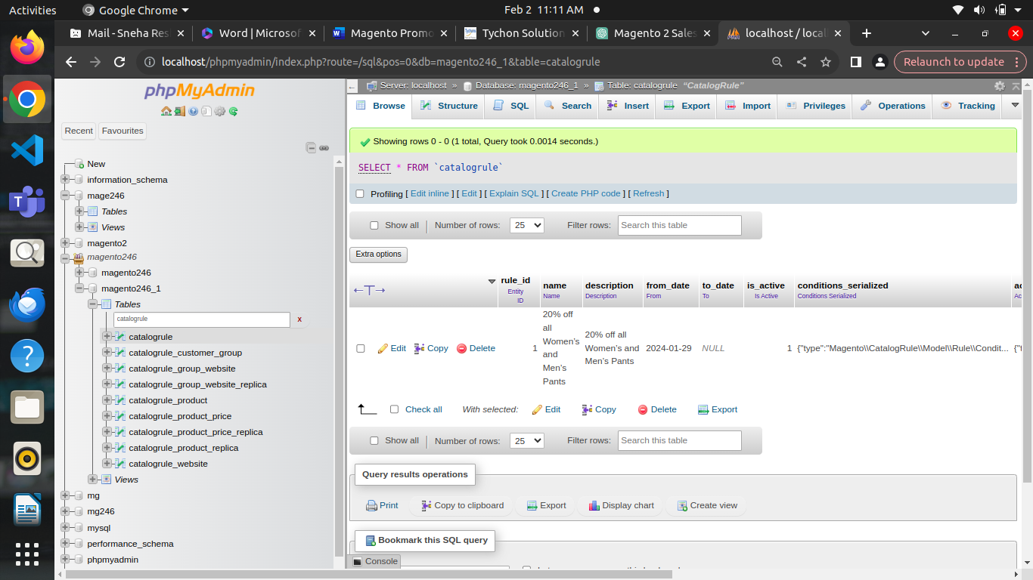

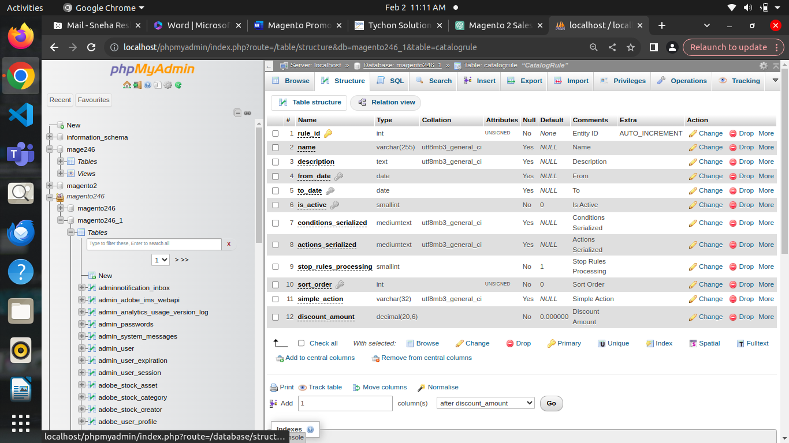

**catalogrule_customer_group**

* **rule_id**: This column stores the ID of the catalog price rule.
* **Customer_group_id:**

This Column stores the ID of the customer group associated with the catalog price rule. Each row in this table represents a mapping between a catalog price rule and a customer group, indicating which customer groups are eligible for the discounts or promotions defined by the rule. For example, if you have a catalog price rule offering a 10% discount on all products for wholesale customers, you would have an entry in this table with the **rule_id** corresponding to the ID of that rule and the **customer_group_id** corresponding to the ID of the wholesale customer group.

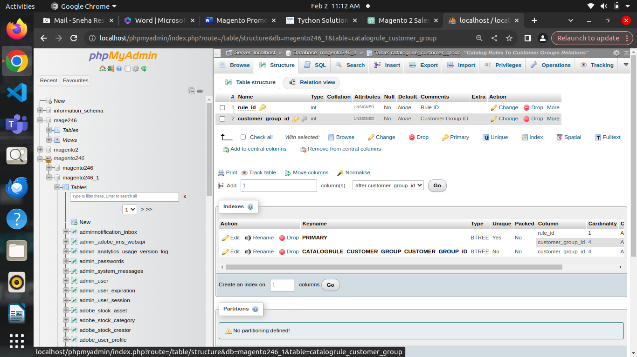

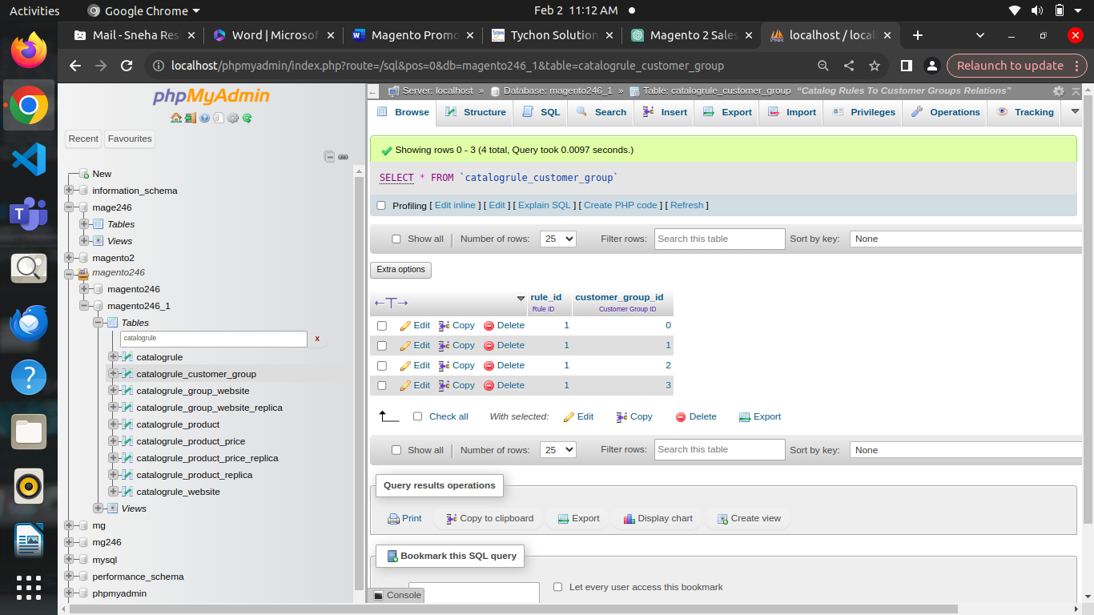

**Catalogrule_group_website**

* **rule_id**: This column stores the ID of the catalog price rule.
* **customer_group_id**: This column stores the ID of the customer group associated with the rule.
* **website_id**: This column stores the ID of the website associated with the rule. It defines which customer groups within specific websites are eligible for the discounts or promotions defined by the rule. For example, if you have a catalog price rule offering a 15% discount on all products for wholesale customers but only for the "US" website, you'd have an entry in this table with the **rule_id** corresponding to the ID of that rule, the **customer_group_id** corresponding to the ID of the wholesale customer group, and the **website_id** corresponding to the ID of the "US" website.2

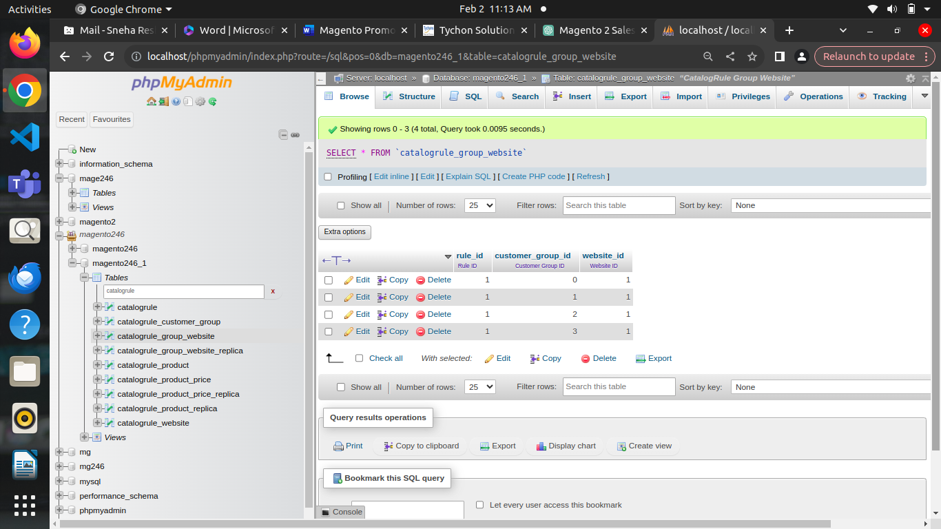

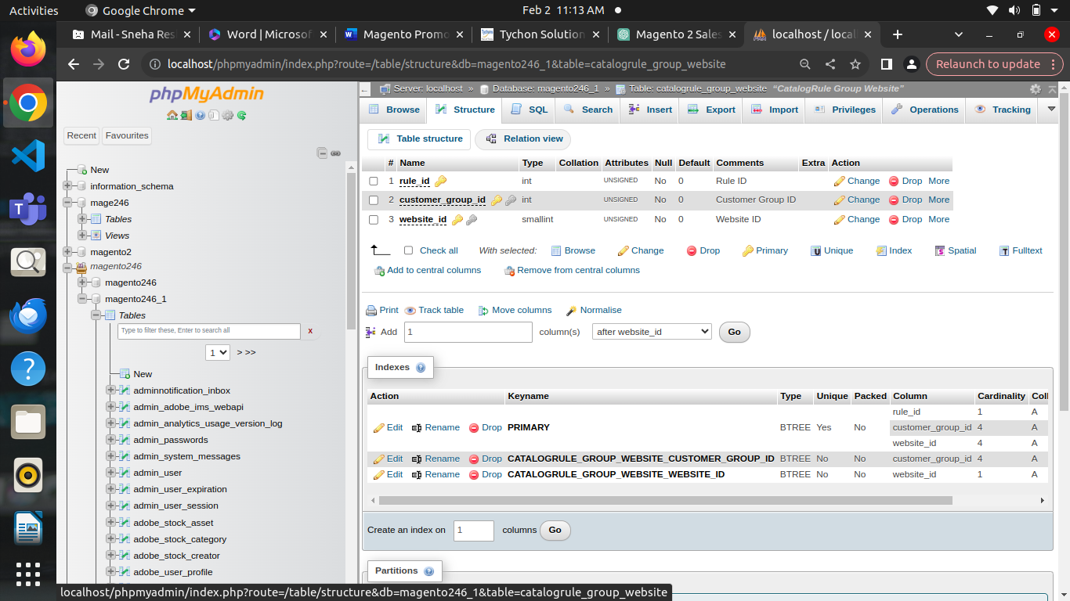

**Catalogrule_group_website_replica**

* The **catalogrule_group_website_replica** table in Magento 2 is a part of the database schema related to catalog price rules, like the **catalogrule_group_website** table.
* this table is a replica table, it is used for indexing and optimization purposes rather than direct manipulation of data.
* In Magento's indexing mechanism, replica tables are often used to speed up data retrieval and improve performance. They are periodically synchronized with the main tables to reflect any changes or updates.
* **rule_id**: This column stores the ID of the catalog price rule.
* **customer_group_id**: This column stores the ID of the customer group associated with the rule.
* **website_id**: This column stores the ID of the website associated with the rule.

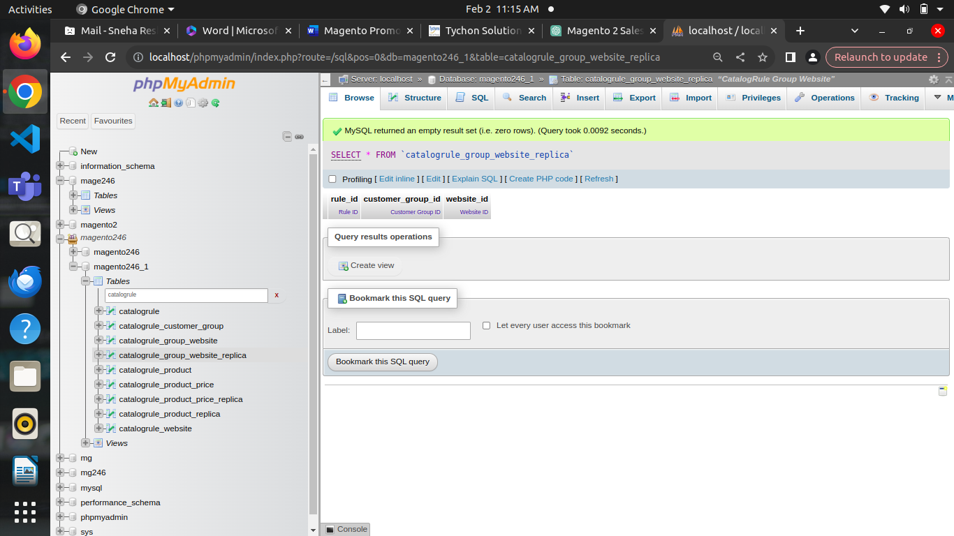

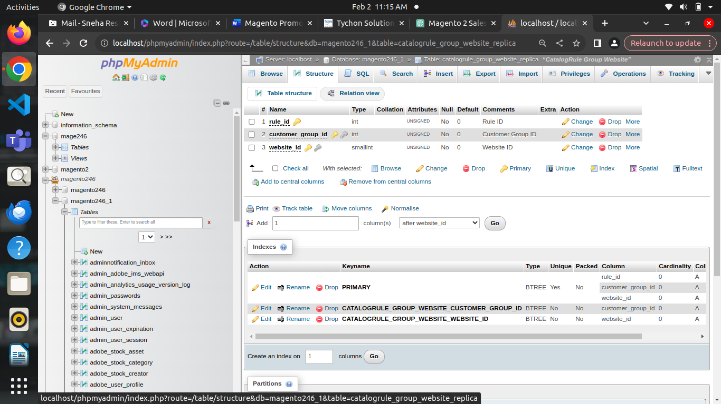

**Catalogrule_product:**

* **rule_id:** This column stores the ID of the catalog price rule.
* **from_time:** This column stores the start date and time for the rule to be applied to the product. It is a Unix timestamp.
* **to_time:** This column stores the end date and time for the rule to be applied to the product. It is a Unix timestamp.
* **customer_group_id:** This column stores the ID of the customer group for which the rule is applicable.
* **product_id**: This column stores the ID of the product to which the rule applies.
* **action_operator**: This column specifies the operator used to apply the action of the rule (e.g., "by_percent", "by_fixed").
* **action_amount**: This column stores the amount of the discount to be applied based on the action specified.
* **action_stop**: This column indicates whether further rules should be processed after this rule is applied (0 for no, 1 for yes).
* For example, if there's a catalog price rule offering a 20% discount on a specific product for logged-in customers belonging to a particular customer group, you'd find an entry in this table with the **rule_id** corresponding to the ID of that rule, **customer_group_id** corresponding to the ID of the customer group, and **product_id** corresponding to the ID of the product, along with the relevant time frame, action, and discount amount.
* **action_stop**: This column is not typically found in the **catalogrule_product** table. It's usually present in tables like **catalogrule** and indicates whether further rules should be processed after a specific rule is applied.
* **sort_order**: Again, this column is not directly associated with the **catalogrule_product** table. It's commonly found in tables like **catalogrule** and determines the order in which rules are processed.
* **website_id**: Similarly, the **website_id** column is not usually part of the **catalogrule_product** table. It's often found in tables like **catalogrule_website** or **catalog_product_website** and associates products or rules with specific websites in a multi-website setup.

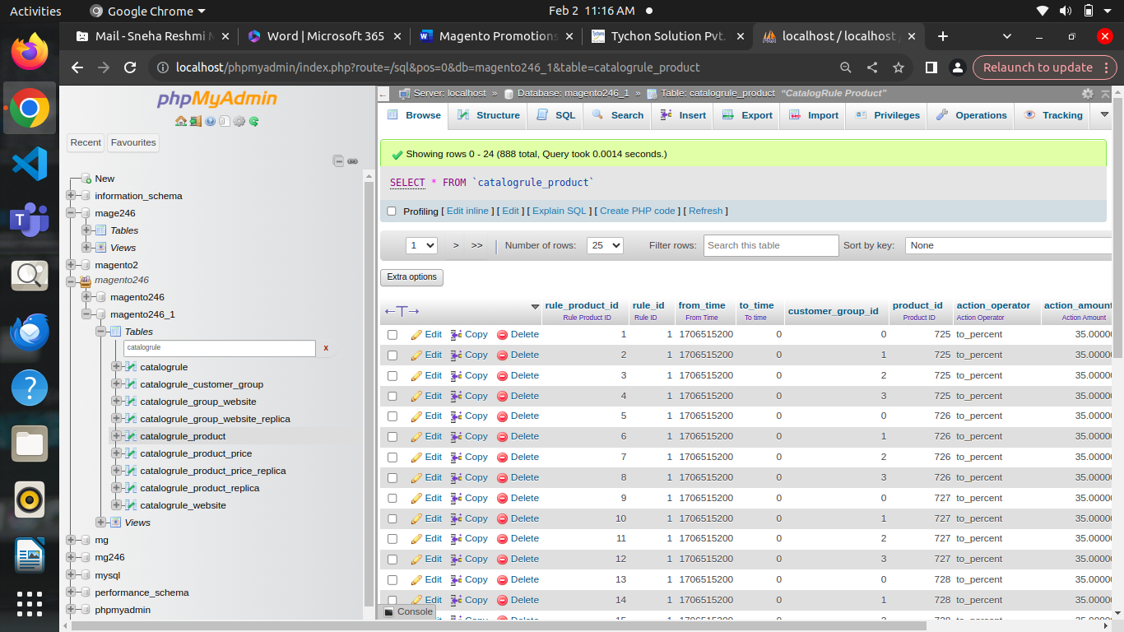

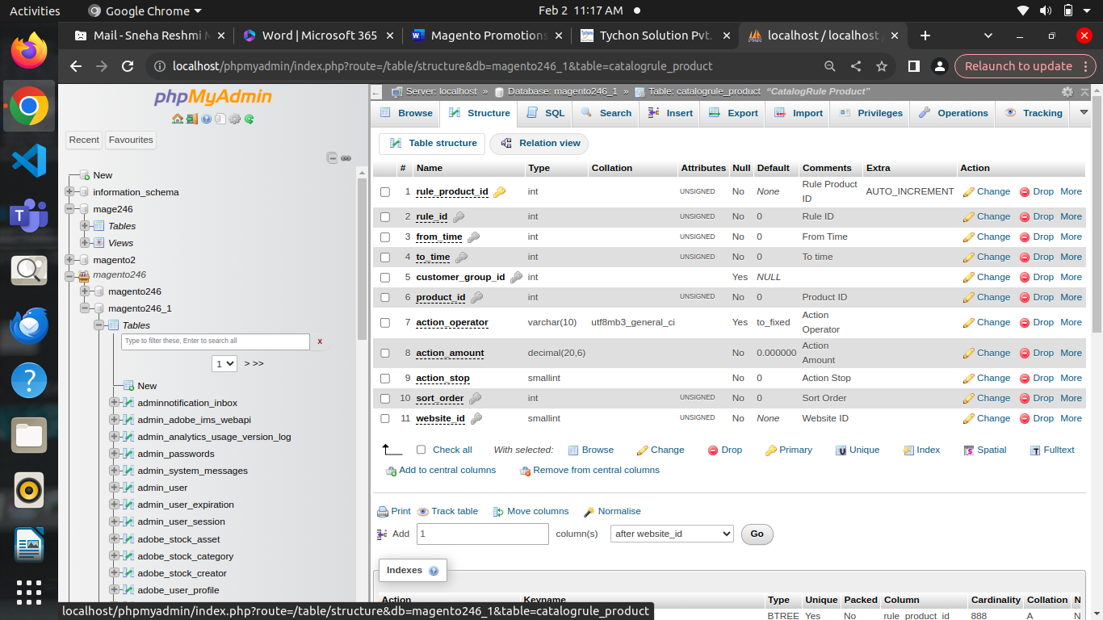

**Catalogrule_product_price**

* **rule_product_price_id:** Primary key identifier for each entry in the table.
* **rule_date:** The date when the price rule is applied.
* **website_id:** The ID of the website to which the price rule is applied.
* **customer_group_id**: The ID of the customer group to which the price rule is applied.
* **product_id**: The ID of the product affected by the price rule.
* **rule_price**: The discounted price of the product after the price rule is applied.
* **latest_start_date**: The start date of the most recent application of the price rule.
* **earliest_end_date**: The end date of the earliest application of the price rule.

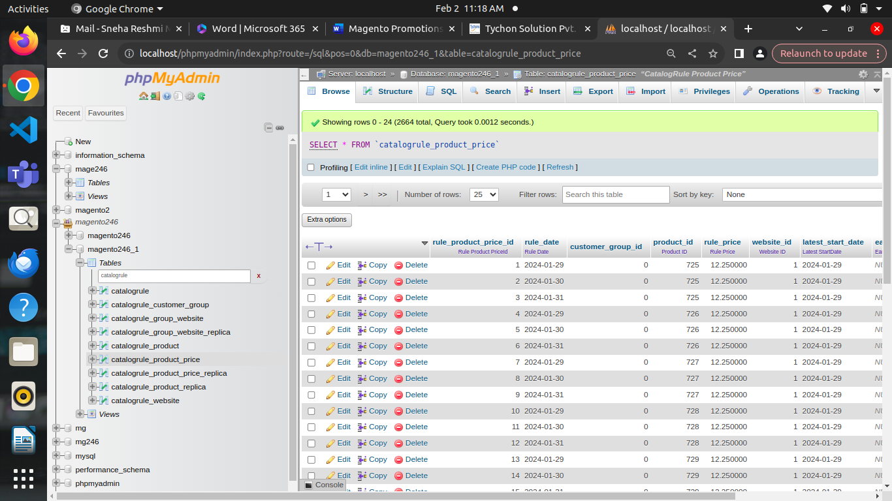

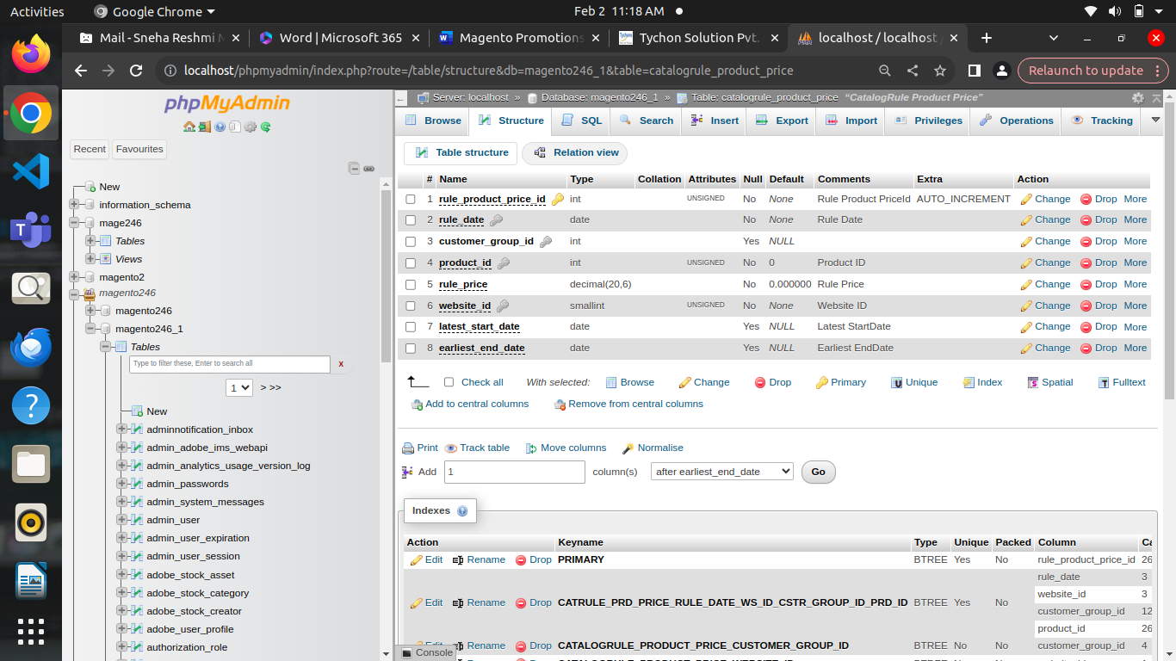

**Catalogrule_product_price_replica**

* The catalogrule_product_price_replica table generally contains replicated data from the catalogrule_product_price table. This replication process is often scheduled to occur at intervals or triggered by specific events, ensuring that the replica table stays up-to-date with the latest pricing information.
* **rule_product_price_id**: Primary key identifier for each entry in the table.
* **rule_date**: The date when the price rule is applied.
* **website_id**: The ID of the website to which the price rule is applied.
* **customer_group_id**: The ID of the customer group to which the price rule is applied.
* **product_id**: The ID of the product affected by the price rule.
* **rule_price**: The discounted price of the product after the price rule is applied.
* **latest_start_date**: The start date of the most recent application of the price rule.
* **earliest_end_date**: The end date of the earliest application of the price rule.

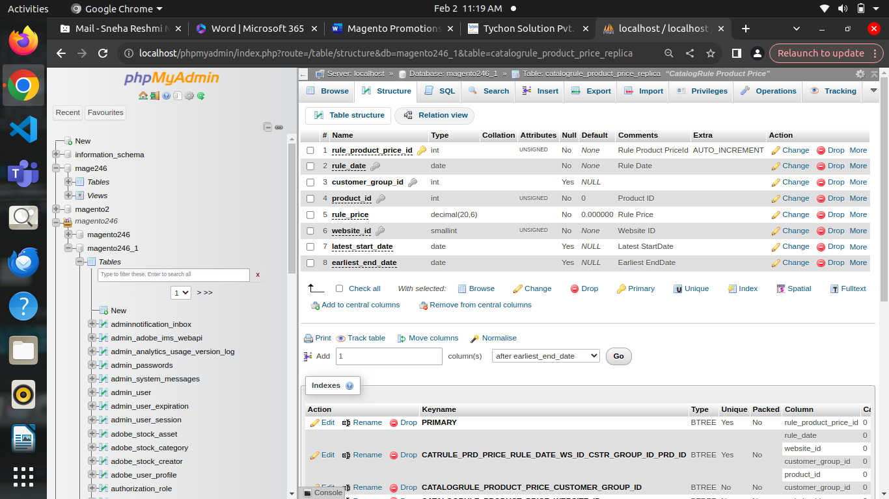

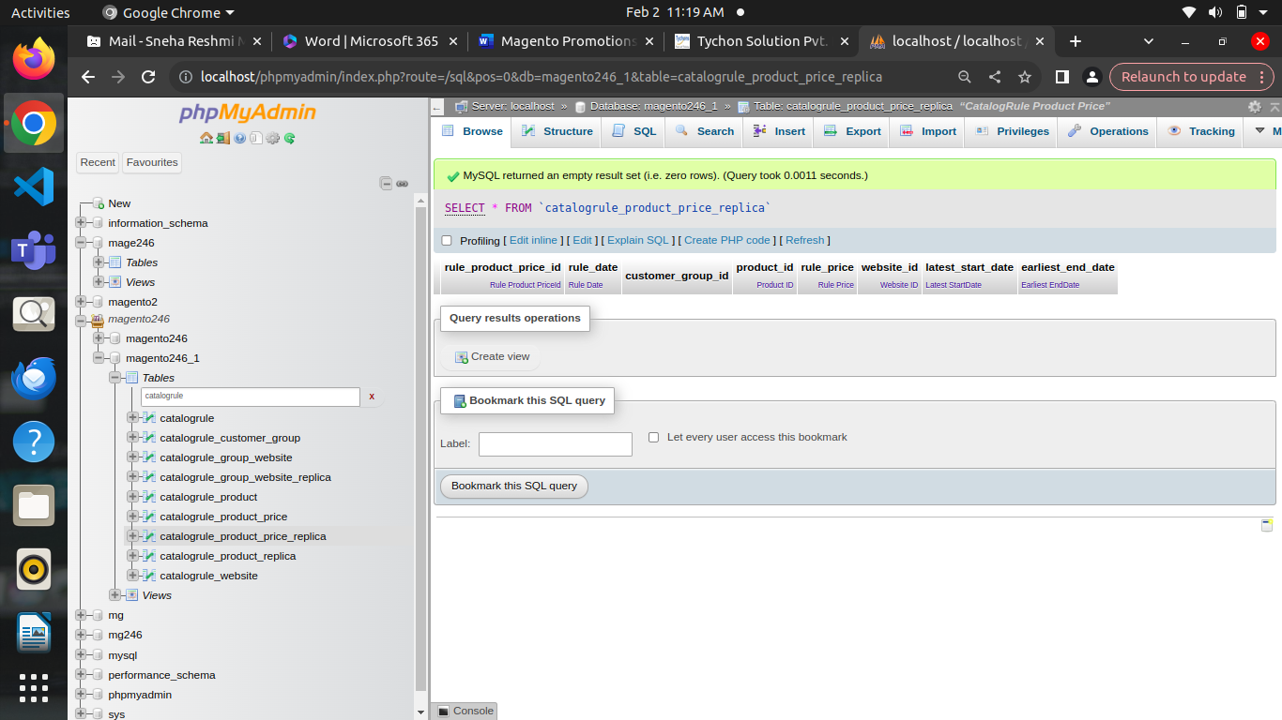

**Catalogrule_product_replica:**

* The **catalogrule_product_replica** table typically includes data about products affected by catalog price rules.
* **rule_product_id**: Primary key identifier for each entry in the table.
* **rule_id**: The ID of the catalog price rule.
* **from_time**: The start time of the rule's application period.
* **to_time**: The end time of the rule's application period.
* **website_id**: The ID of the website to which the rule is applied.
* **customer_group_id**: The ID of the customer group to which the rule is applied.
* **product_id**: The ID of the product affected by the rule.
* **action_operator**: Specifies how the rule is applied to the product (e.g., "by percent", "to fixed price").
* **action_amount**: The amount by which the product's price is adjusted based on the rule.
* **sort_order**: Specifies the priority of the rule if multiple rules apply to the same product.
* **action_stop:**

* If **action_stop** is set to 0, it means that the catalog rule does not stop further processing of rules for the affected product. Other rules may continue to be applied.

* If **action_stop** is set to 1, it means that the catalog rule stops further processing of rules for the affected product. Once this rule is applied, subsequent rules are not applied to the same product.

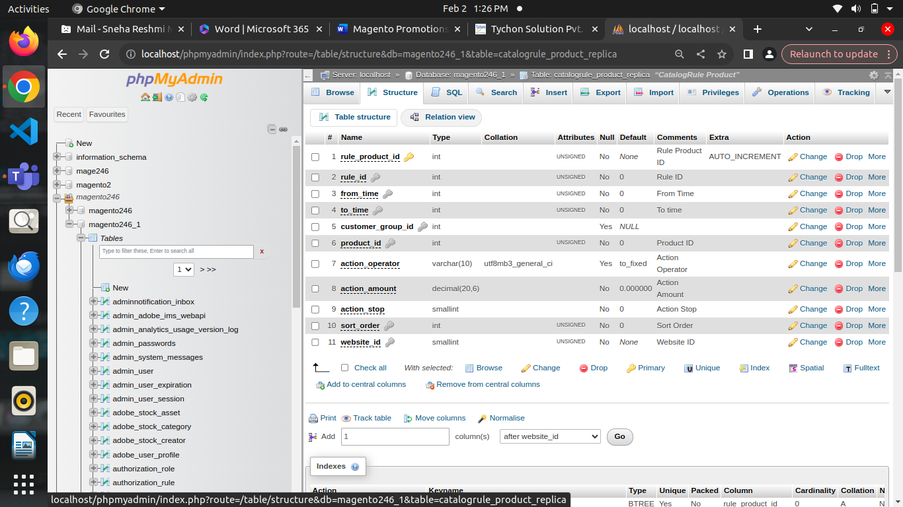



**Catalogrule_website:**

* **rule_id**: This column stores the ID of the catalog price rule.
* **website_id**: The ID of the website to which the rule is applied.

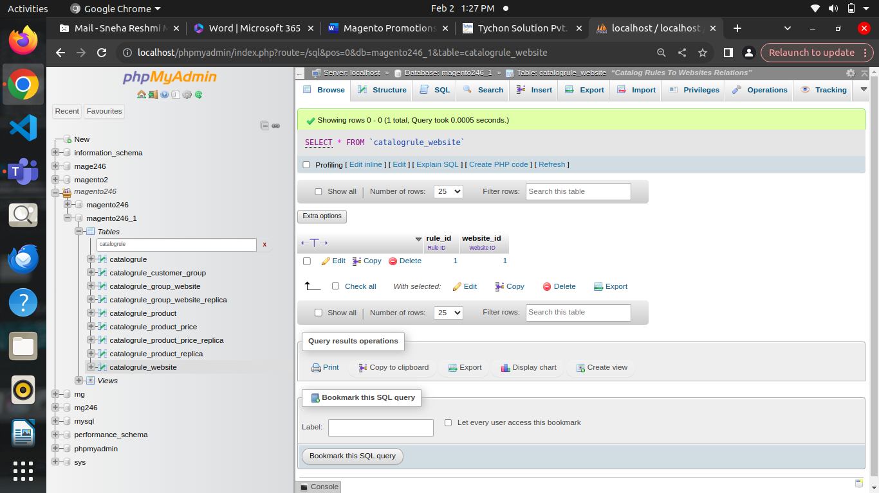

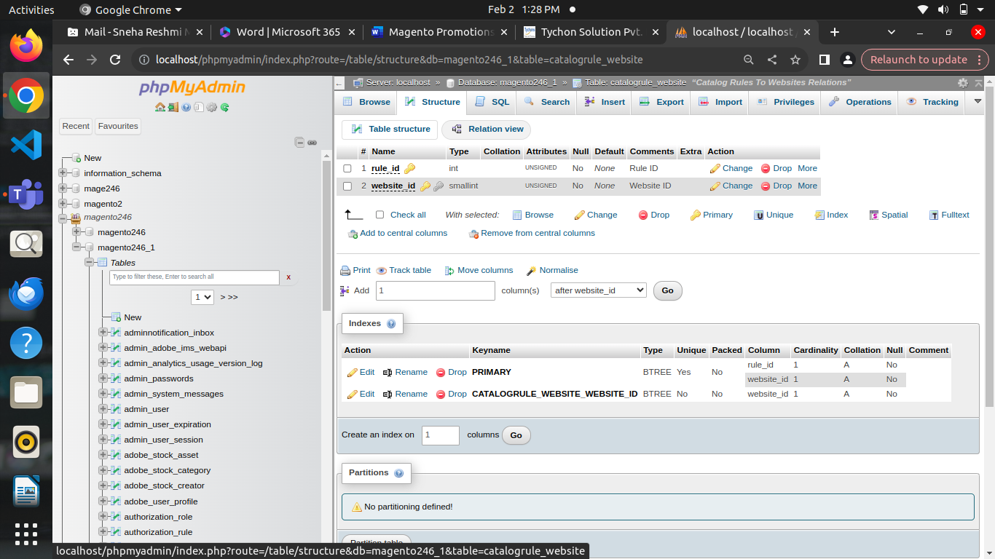

**CartPrice Rule Tables**

* Salesrule
* Salesrule_coupon
* Salesrule_coupon_aggregated
* Salesrule_coupon_aggregated_order
* Salesrule_coupon_aggregated_updated
* Salesrule_coupon_usage
* Salesrule_customer
* Salesrule_customer_group
* Salesrule_label
* Salesrule_Product_attribute
* Salesrule_website

**Salesrule**

* **rule_id:** A unique identifier for each sales rule.
* **name:** The name of the sales rule, which helps to identify it.
* **description:** Additional information or details about the sales rule.
* **from_date and to_date:** The start and end dates for the validity of the sales rule.
* **is_active:** A flag indicating whether the sales rule is currently active or not.
* **conditions_serialized:** Serialized data representing the conditions that must be met for the rule to apply.
* **actions_serialized:** Serialized data representing the actions that will be taken when the rule is applied (e.g., discount amount, percentage).
* **stop_rules_processing:** A flag indicating whether to stop processing further rules once this rule is applied.
* **is_advanced**: This column indicates whether the rule uses advanced conditions or not. Advanced conditions allow for more complex rule configurations beyond basic conditions like product attributes or cart attributes.
* **product_ids**: This column may contain a list of specific product IDs to which the rule applies. If populated, the discount specified by the rule would only be applied to the products listed here.
* **sort_order**: This column determines the order in which sales rules are applied. Lower values indicate higher priority, meaning rules with lower sort order values will be processed first.
* **simple_action**: This column specifies the type of action to take when the conditions of the rule are met. values include "by_fixed", "by_percent", "cart_fixed", "buy_x_get_y", etc., indicating fixed amount discounts, percentage discounts, fixed amount discounts for the whole cart, or buy X get Y free promotions, respectively.
* **discount_amount**: This column specifies the amount or percentage of discount applied when the rule conditions are met, depending on the value of **simple_action**.
* **discount_qty**: This column may specify the quantity of items to which the discount applies. For example, if the rule is "Buy 3, get 1 free," this would be set to 1.
* **discount_step**: This column indicates the interval at which the discount is applied. For example, if set to 2, the discount might be applied every 2 items.
* **apply_to_shipping**: This column likely indicates whether the discount specified by the rule applies to shipping costs as well.
* **times_used**: This column tracks how many times the rule has been applied to orders.
* **is_rss**: This column may indicate whether the rule is enabled for RSS feed generation or not.
* **coupon_type**: This column specifies the type of coupon associated with the rule, if any. Possible values include "no_coupon", "specific_coupon", or "auto_generated", indicating no coupon, a specific coupon code, or automatically generated coupons, respectively.
* **use_auto_generation**: This column may indicate whether auto-generation of coupons is enabled for the rule.
* **uses_per_coupon**: This column specifies how many times a specific coupon can be used.
* **simple_free_shipping**: This column may indicate whether the rule provides free shipping when conditions are met.

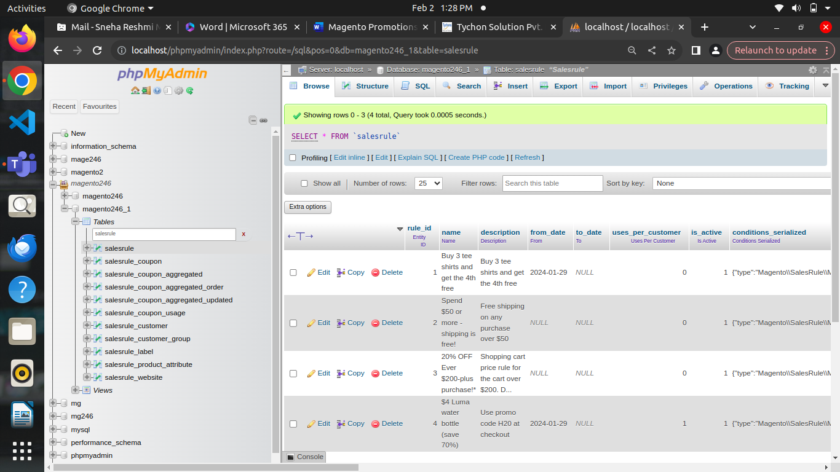

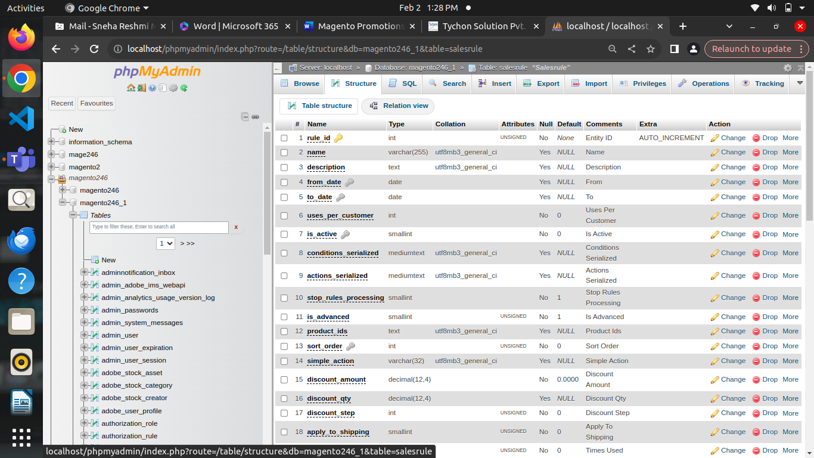

**Salesrule_coupon**

* **coupon_id**: A unique identifier for each coupon.
* **rule_id**: The identifier of the sales rule (shopping cart price rule) to which the coupon belongs.
* **code**: The coupon code itself, which customers enter during checkout to apply the discount specified by the associated rule.
* **usage_limit**: Specifies the maximum number of times the coupon can be used overall.
* **usage_per_customer**: Specifies the maximum number of times a single customer can use the coupon.
* **times_used**: Tracks how many times the coupon has been used.
* **expiration_date**: The date and time when the coupon expires and can no longer be used.
* **type**: Specifies the type of coupon, such as "specific," "general," or "auto."
* **is_primary**: Indicates whether the coupon is the primary one applied in a multi-coupon scenario.
* **created_at**: Timestamp indicating when the coupon was created.

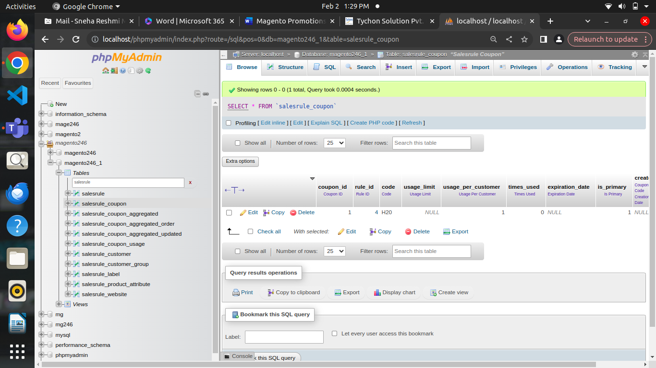

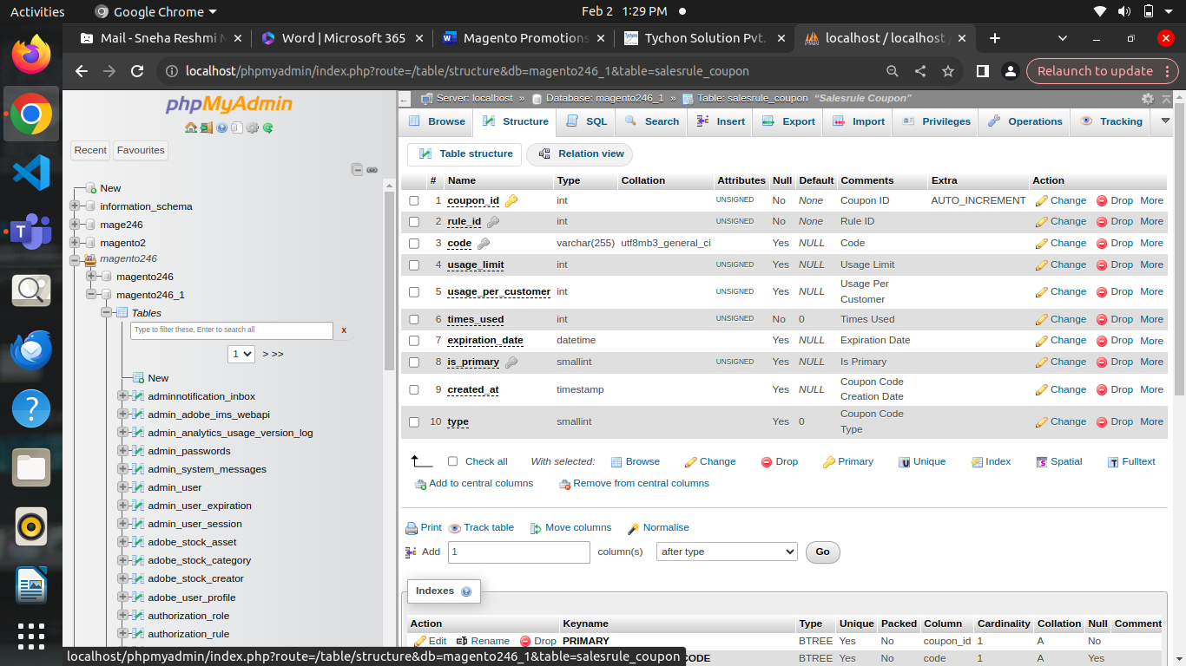

**Salesrule_coupon_aggregated**

* **id**: A unique identifier for each record in the aggregated table.
* **period**: The period over which the data is aggregated, such as daily, monthly, or yearly.
* **store_id**: The store view ID for which the data is aggregated.
* **rule_id**: The identifier of the sales rule (shopping cart price rule) associated with the aggregated data.
* **coupon_code:** The coupon code associated with the aggregated data.
* **coupon_uses**: The total number of times the coupon has been used within the specified period.
* **subtotal_amount**: The total amount of order subtotals for orders where the coupon was used within the specified period.
* **discount_amount**: The total discount amount applied using the coupon within the specified period.
* **total_amount**: The total order amount for orders where the coupon was used within the specified period.
* **subtotal_amount_actual**: This column represents the actual subtotal amount for orders where the coupon was used within the specified period. It differs from **subtotal_amount**, which might represent a calculated or derived subtotal amount.
* **discount_amount_actual**: Similarly, this column represents the actual discount amount applied using the coupon within the specified period. It provides a more accurate reflection of the discounts applied.
* **total_amount_actual**: This column represents the actual total order amount for orders where the coupon was used within the specified period. It differs from **total_amount**, which might represent a calculated or derived total amount.
* **rule_name**: This column stores the name or identifier of the sales rule associated with the aggregated data. It provides a reference to the specific rule that the aggregated data pertains to.

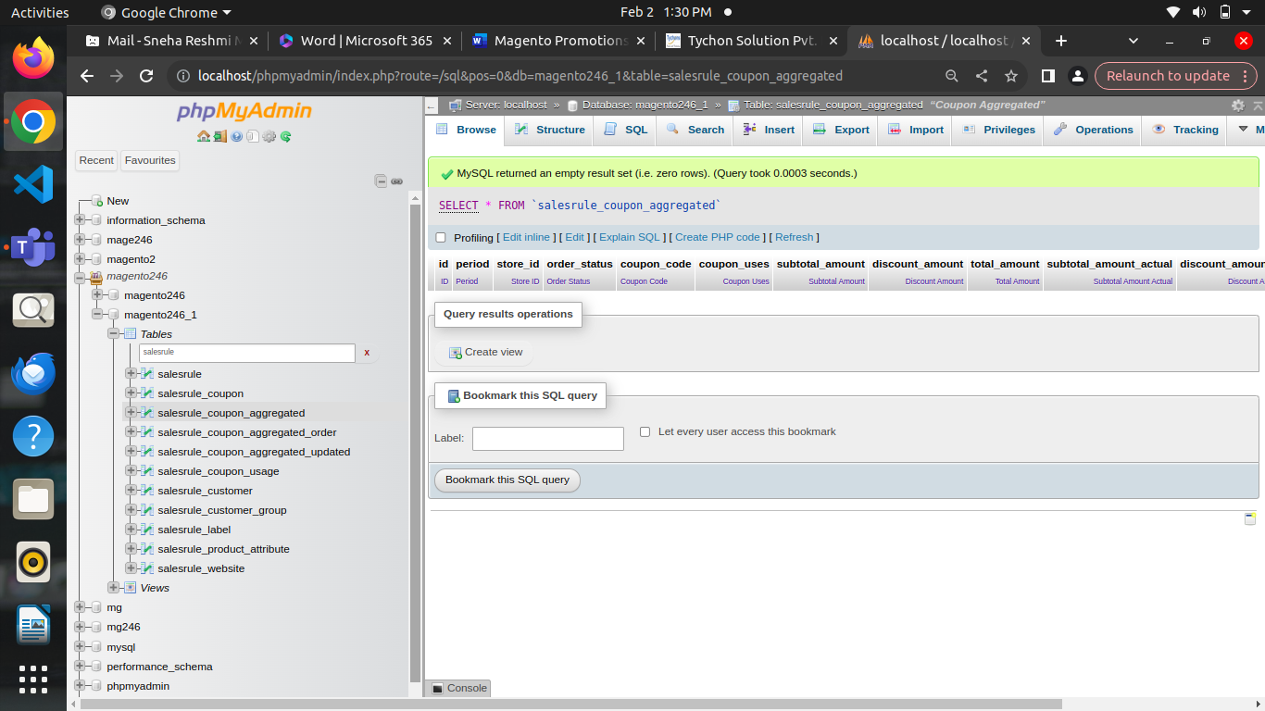

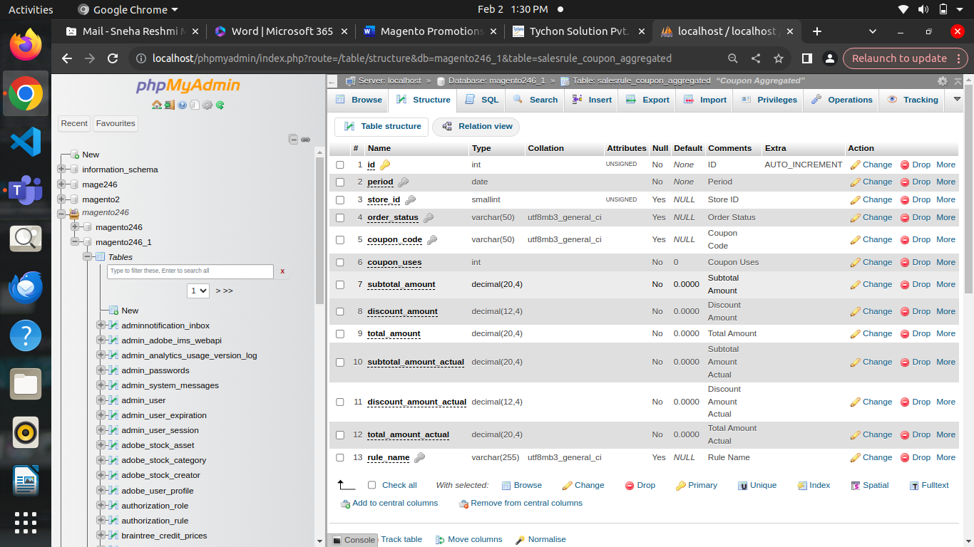

**Salesrule_coupon_aggregated_order:**

* **id**: A unique identifier for each record in the aggregated table.
* **period**: The period over which the data is aggregated, such as daily, monthly, or yearly.
* **store_id**: The store view ID for which the data is aggregated.
* **order_status**: The status of the orders included in the aggregation (e.g., "complete", "processing", "closed").
* **coupon_code**: The coupon code associated with the aggregated data.
* **coupon_uses**: The total number of times the coupon has been used within the specified period and for orders with the specified status.
* **subtotal_amount**: The total amount of order subtotals for orders where the coupon was used within the specified period and for orders with the specified status.
* **discount_amount**: The total discount amount applied using the coupon within the specified period and for orders with the specified status.
* **total_amount**: The total order amount for orders where the coupon was used within the specified period and for orders with the specified status.
* **rule_name**: This column stores the name or identifier of the sales rule associated with the aggregated data. It provides a reference to the specific rule

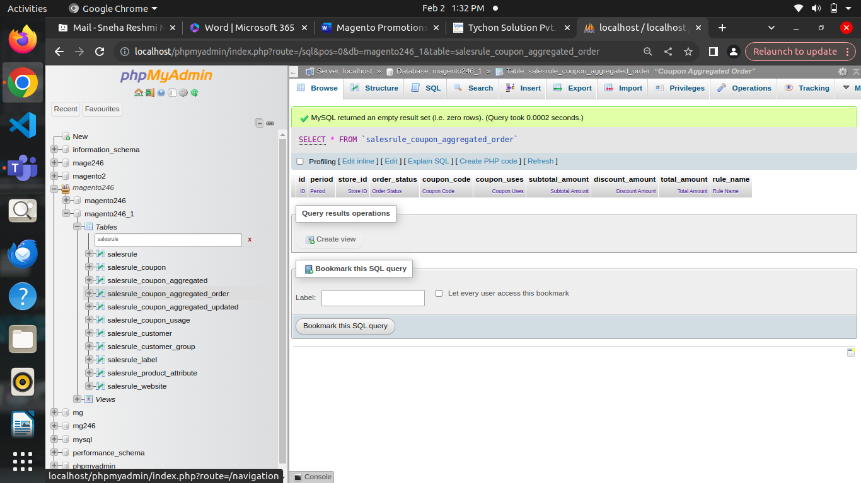

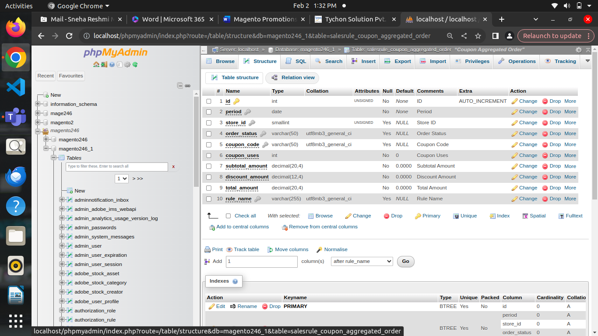

**Salesrule_coupon_aggregated_updated**

* **id**: A unique identifier for each record in the aggregated table.
* **period**: The period over which the data is aggregated, such as daily, monthly, or yearly.
* **store_id**: The store view ID for which the data is aggregated.
* **rule_id**: The identifier of the sales rule (shopping cart price rule) associated with the aggregated data.
* **coupon_code**: The coupon code associated with the aggregated data.
* **coupon_uses**: The total number of times the coupon has been used within the specified period.
* **subtotal_amount**: The total amount of order subtotals for orders where the coupon was used within the specified period.
* **discount_amount**: The total discount amount applied using the coupon within the specified period.
* **total_amount**: The total order amount for orders where the coupon was used within the specified period.
* **subtotal_amount_actual**: This column represents the actual subtotal amount for orders where the coupon was used within the specified period. It might differ from **subtotal_amount**, which could represent a calculated or derived subtotal amount.
* **discount_amount_actual**: Similarly, this column represents the actual discount amount applied using the coupon within the specified period. It provides a more accurate reflection of the discounts applied.
* **total_amount_actual**: This column represents the actual total order amount for orders where the coupon was used within the specified period. It differs from **total_amount**, which might represent a calculated or derived total amount.
* **rule_name**: This column stores the name or identifier of the sales rule associated with the aggregated data. It provides a reference to the specific rule that the aggregated data

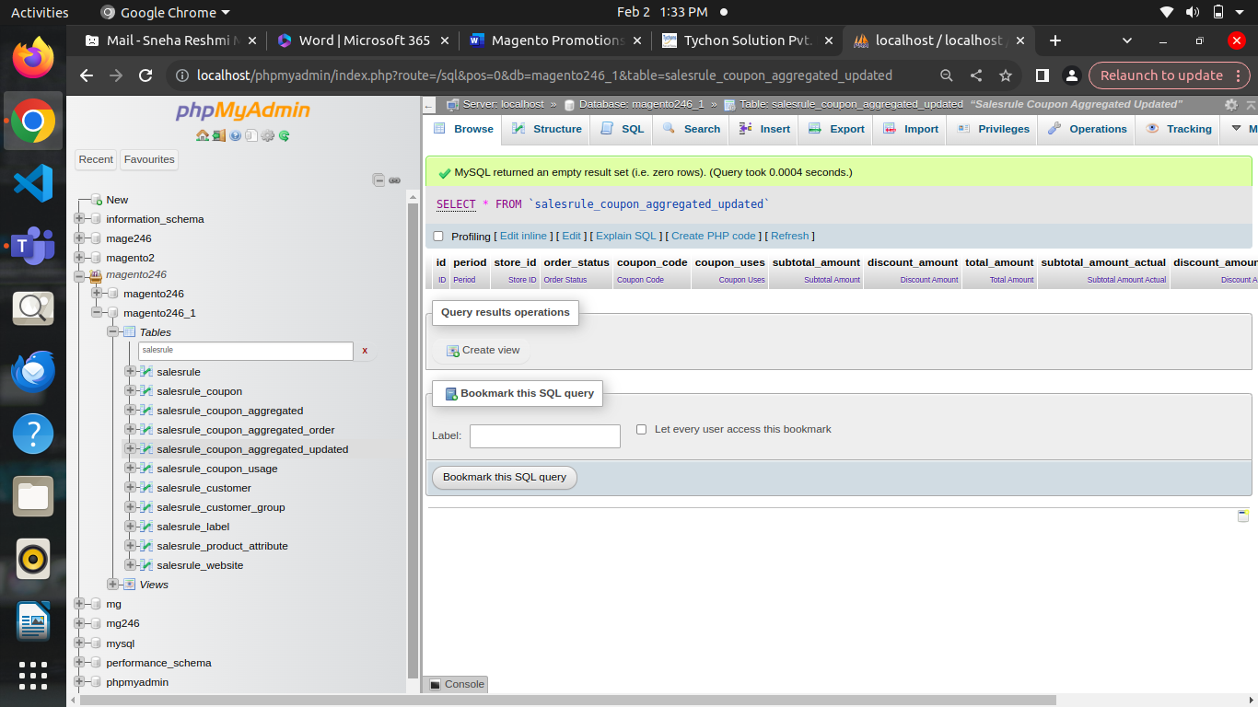

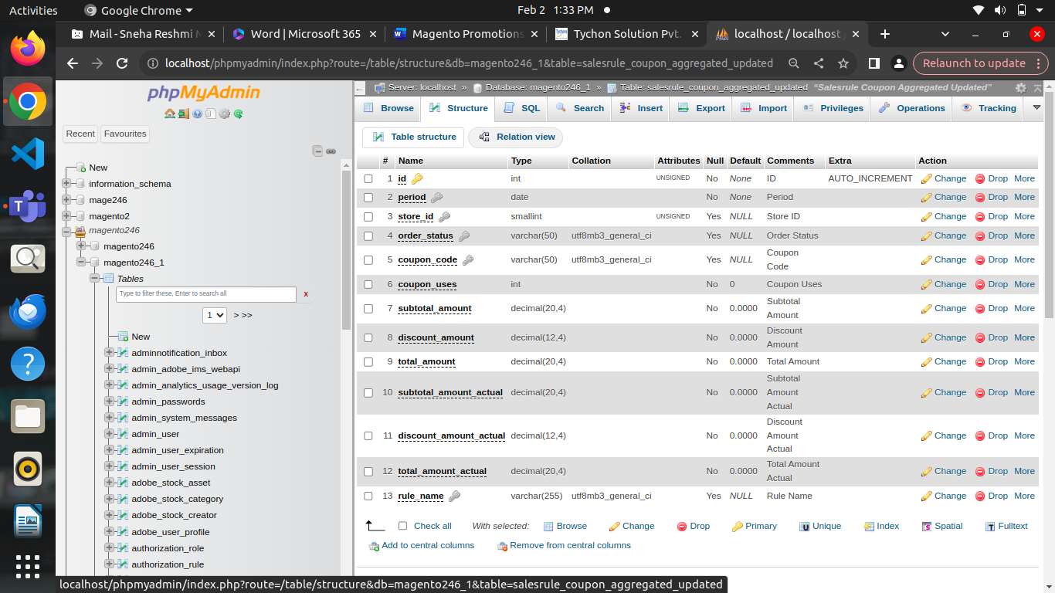

**Salesrule_coupon_usage**

* **coupon_id**: A foreign key referencing the **coupon_id** column in the salesrule_coupon table, indicating the specific coupon being used.
* **customer_id**: The ID of the customer who used the coupon. If a coupon is used by a guest customer (not logged in), this field might be null.
* **times_used**: The number of times the coupon has been used by the specific customer.

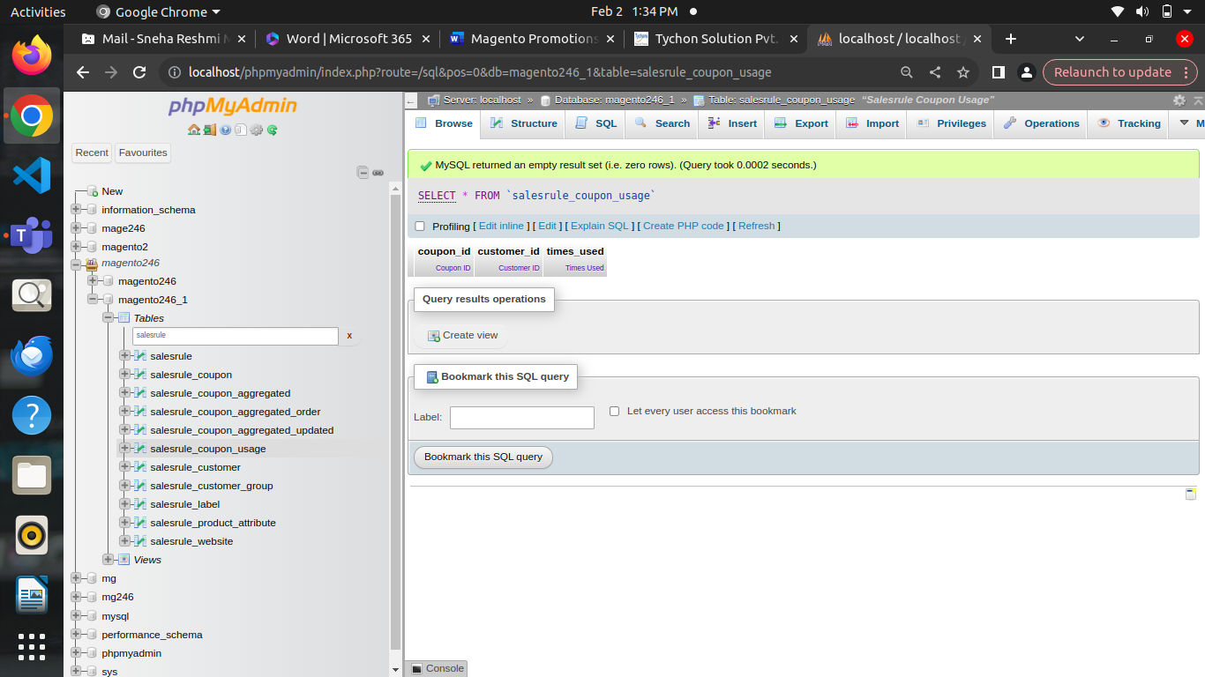

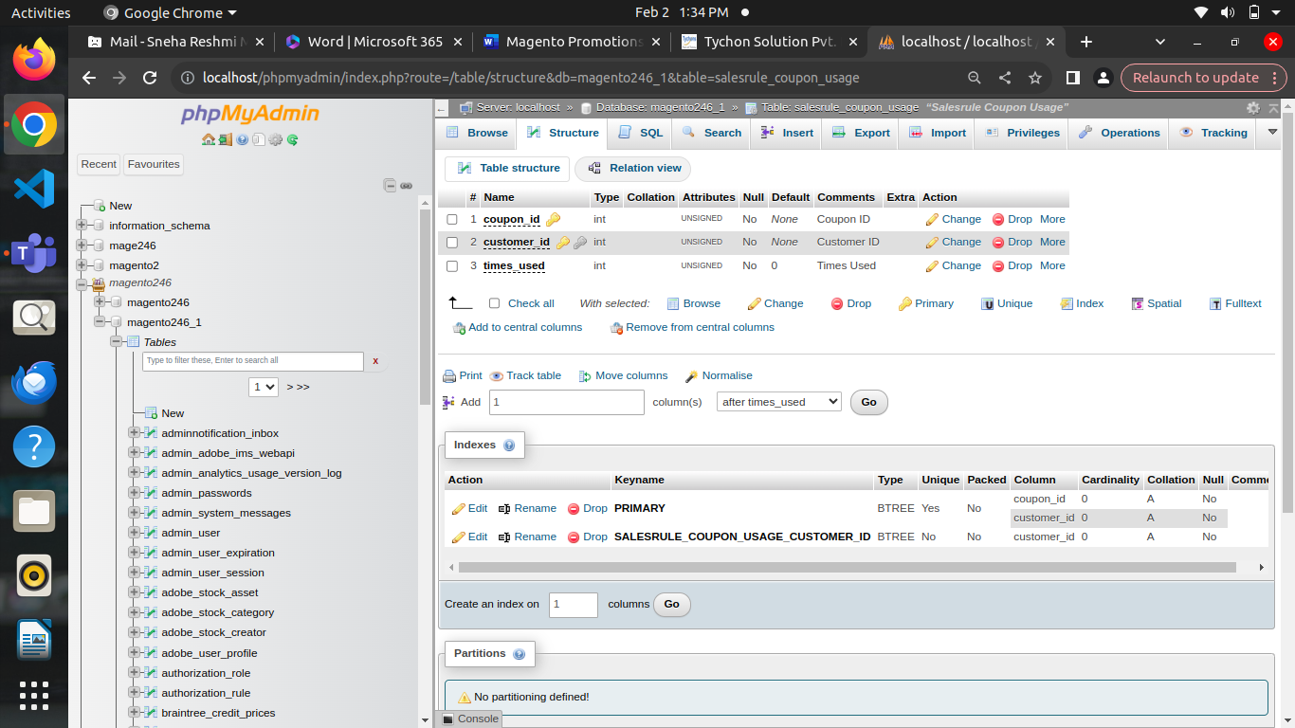

**Salesrule_customer**

* **customer_id:** The ID of the customer who used the coupon. If a coupon is used by a guest customer (not logged in), this field might be null.
* **times_used**: The number of times the coupon has been used by the specific customer.
* **rule_id**: The identifier of the sales rule (shopping cart price rule) to which the coupon belongs.
* **rule_customer_id**: A unique identifier for each record.
* **rule_id**: The ID of the sales rule (shopping cart price rule or catalog price rule) associated with the record.
* **customer_group_id**: The ID of the customer group associated with the sales rule.

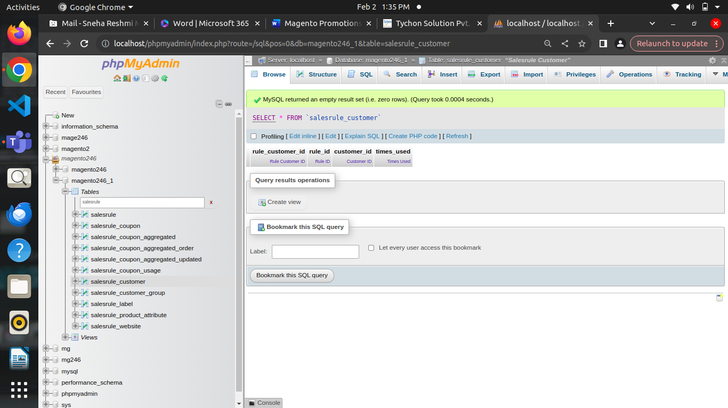

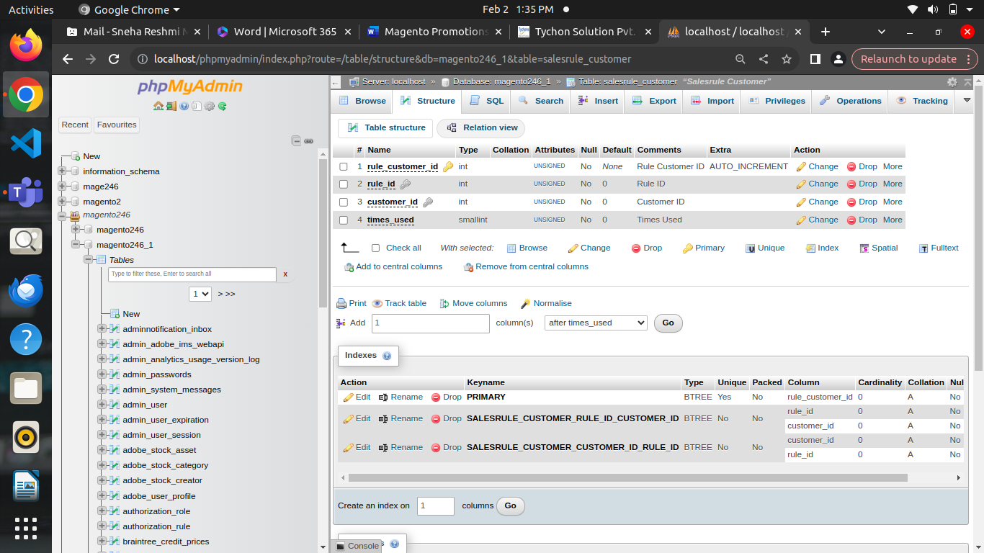

**Salesrule_label:**

* **rule_id**: The ID of the sales rule (shopping cart price rule or catalog price rule) associated with the label.
* **store_id**: The store view ID for which the label is defined. This allows for store-specific labels.
* **label_id**: A unique identifier for each record in the table.
* **label**: The actual label or name associated with the sales rule. This is the text displayed to users in the storefront or admin panel.

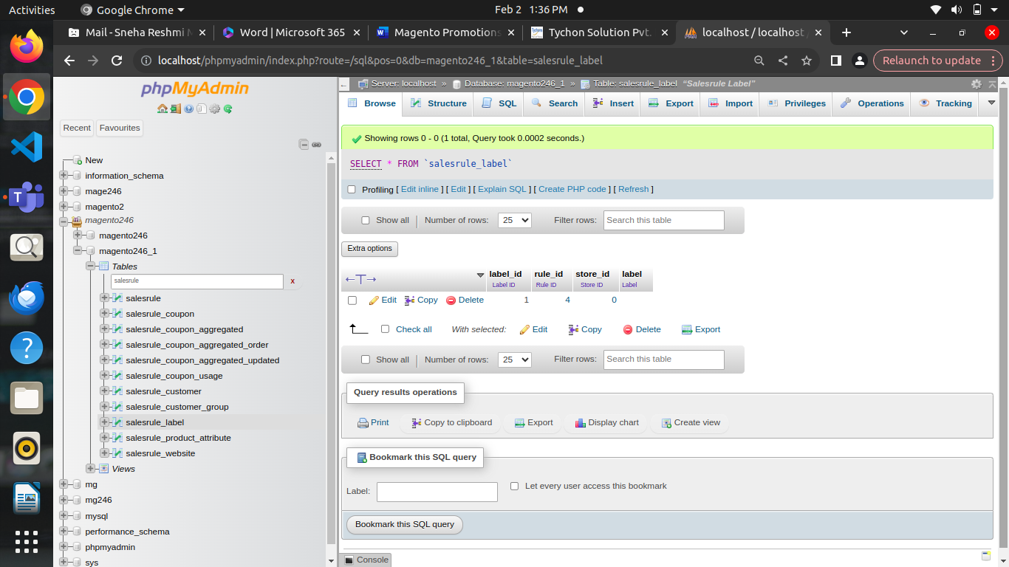

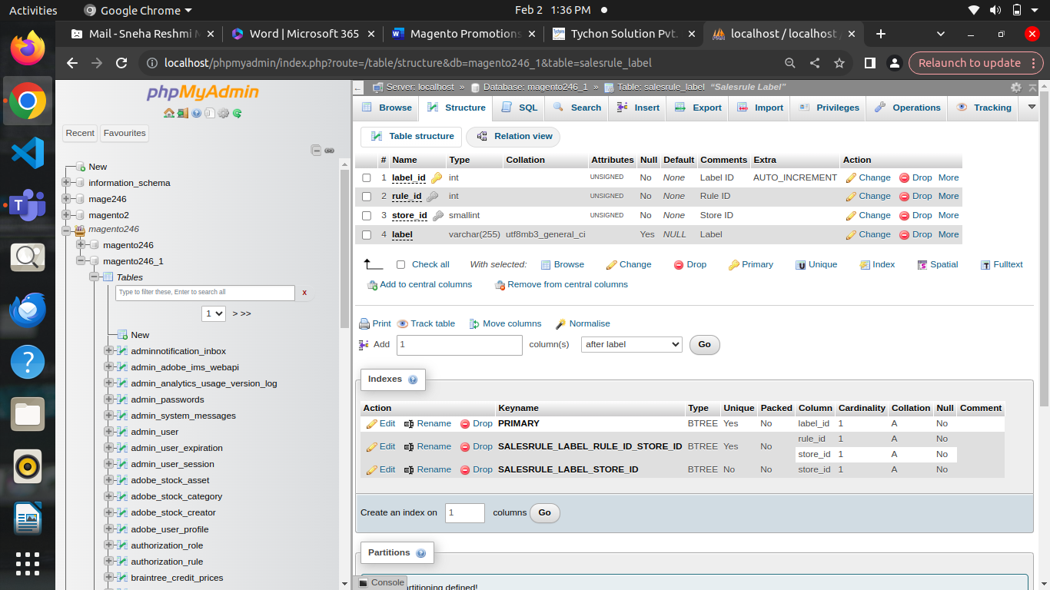

**Salerule_product_attribute:**

* **rule_id**: A foreign key referencing the ID of the sales rule (shopping cart price rule or catalog price rule) associated with the product attribute.
* **website_id**: The ID of the website to which the product attribute condition applies. This allows for website-specific conditions.
* **customer_group_id**: The ID of the customer group to which the product attribute condition applies. This allows for customer group-specific conditions.
* Attribute_id: It could represent identifiers for custom attributes or other related entities.

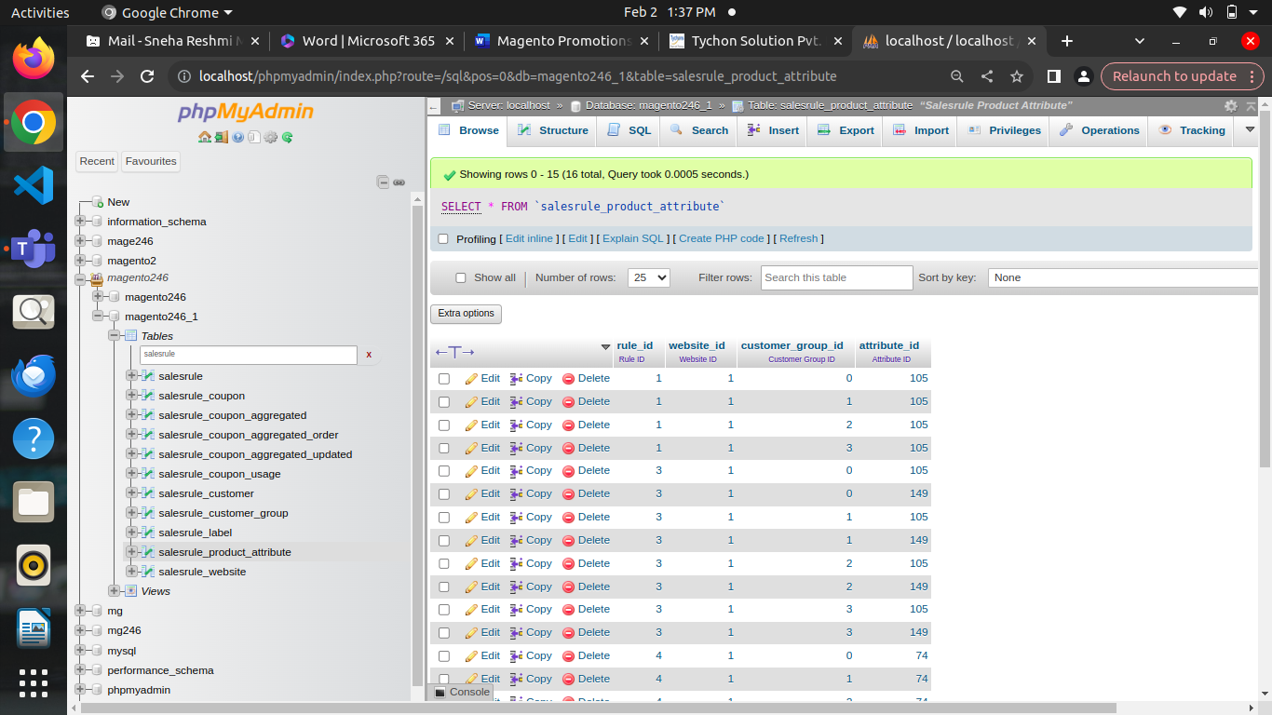

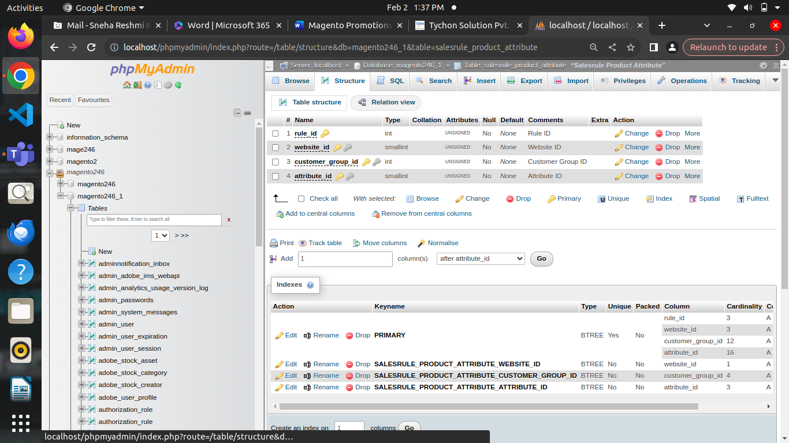

**Salesrule_website:**

* **rule_id**: The ID of the sales rule (shopping cart price rule or catalog price rule) associated with the website mapping.
* **website_id**: The ID of the website to which the sales rule is associated.

